Patient instructions for stool sample testing for parasitic nucleic acids

F-ParaNhO

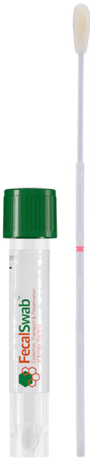
You can get a sample collection kit from any laboratory of the wellbeing services county of South Ostrobothnia.

- Open the Fecalswab® sample collection kit. Open the screw cap of the sample tube and place the tube upright on a flat surface. Be careful not to spill the liquid in the tube!
- Pass stool onto a disposable plate or toilet paper. A bloody diarrhoeal stool is not suitable as a sample. Avoid getting urine into the sample.
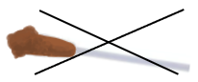
- Remove the sampling swab from the package and rotate it in the stool until an appropriate amount of stool adheres to the swab.
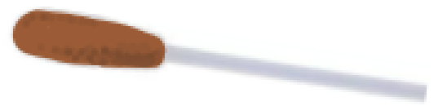
Appropriate amount of stool Too much stool
- Insert the sampling swab into the sample tube. Rotate the swab in the sample tube until the stool dissolves in the liquid inside the tube. Dispose of the sampling swab in the general waste and close the screw cap tightly. Leaked samples cannot be tested. Wash your hands after collecting the sample.
- Write your name, personal identity code and the date and time of sample collection on the label provided with the kit, and attach the label to the sample tube.
- Place the sample tube in a plastic bag (Minigrip or equivalent) and seal it carefully.

Sample storage and delivery to the laboratory
Store the sample at refrigerator temperature. Deliver the sample to the laboratory within 24 hours of collection (to the same location where blood samples may be taken).

Return these instructions with the sample and provide the following information:
Name:
Personal identity code:
Stool sample taken (date):
Country and dates of travel:

